Failed to connect to the network using the LAN V3.0 dongle

Contributor: Eason
Copywriter:张岩

FAQ\Network Communication
Issue introduction
Unable to monitor the inverter remotely over the network
Confirmation of basic information
[Photo]SN number of the inverter and pocket.
[Photo]Router Model.
Confirm that the distance from the LAN dongle to the router does not exceed 50m.
Guidance for installer
Step1. Re-insert the dongle and make sure it is securely plugged in and making good contact. Wake up the inverter LCD display to check Register SN. If the Registration SN on the Dongle appears as "Register SN" on the inverter, the connection between dongle and inverter is normal.
Setting path: About →Inverter →Resister SN
INV side | Dongle side
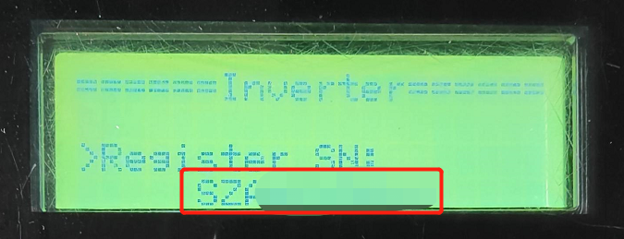  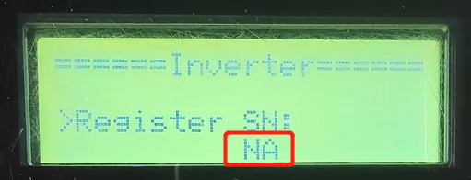 | 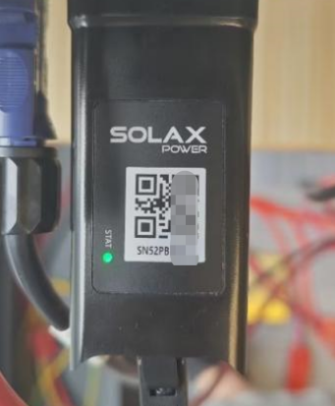
If “NA” is displayed, Check the silkscreen on the dongle's USB port to make sure it is not damaged. re-plug the dongle to make a good connection between the inverter and the dongle.
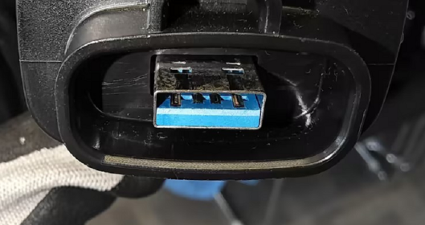
If “NA” is still displayed,Remove the internal components of the pocket and verify whether the pocket is damaged.First, locate the recessed clips on both sides of the pocket.
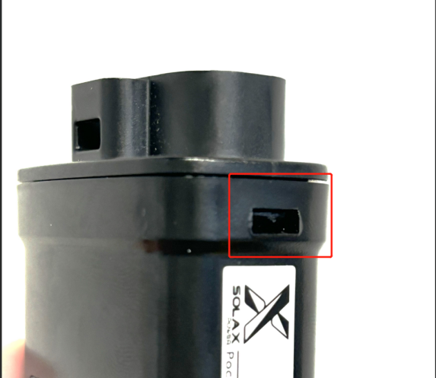
Use a flat-head screwdriver to find a downward-slanting angle, insert it into the slot, and gently pry downward. | Continue until the screwdriver is positioned as shown in the image, perpendicular to the side of the pocket.
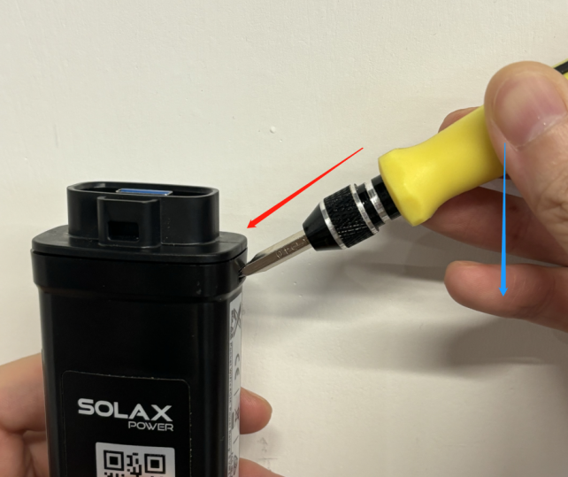 | 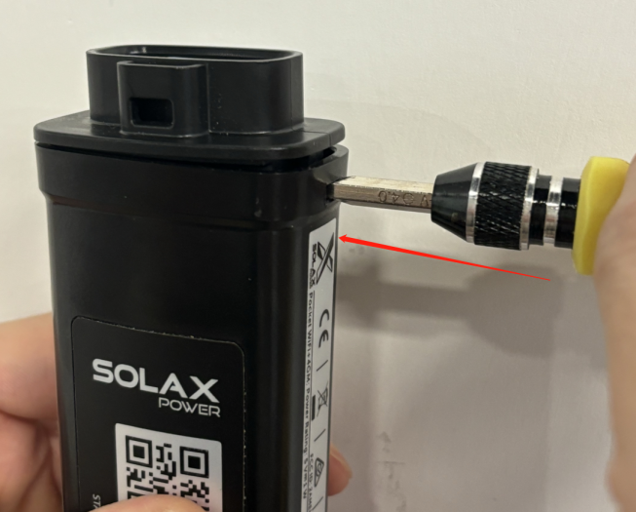
Do the same on the other side, then remove the front cover and take out the internal components.（There may be communication cables adhered inside; as shown in the image, removing half of them is sufficient.）
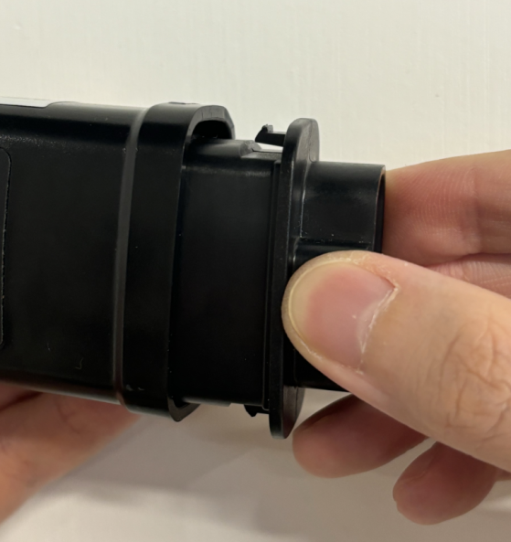 |  | 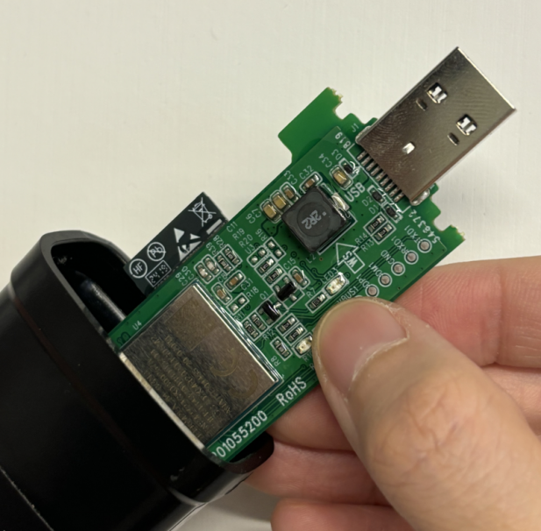
Reinsert the inverter and check if it successfully connects to the network.If not, replace the pocket.
If the connection is successful, return to Step 1 and reinsert the pocket to ensure it is securely connected.When restoring the pocket, make sure the USB is inserted into the position shown in the image, and the side of the top cover with the hole should face the same direction as the side with the QR code.
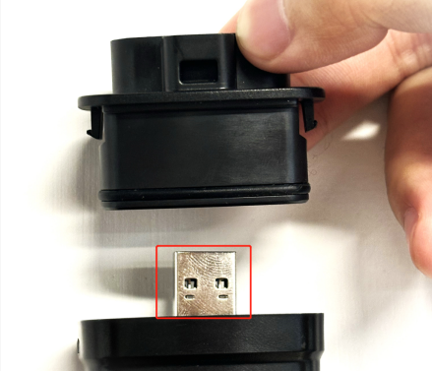

Step2: Connect the router to the computer using LAN connection, and check whether the computer can open the web page. Ensure that the router is functioning properly under the LAN network.
Step3: Then, in the search bar of the computer, type 'cmd' to open the Command Prompt window.
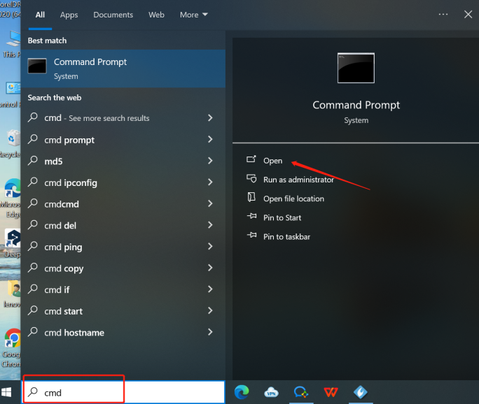
In the window, type `ping mqtt101.solaxcloud.com` and press Enter to view the results. Normally the circled area show ‘Lost=0’ , indicating normal operation. Take a screenshot to save this image.
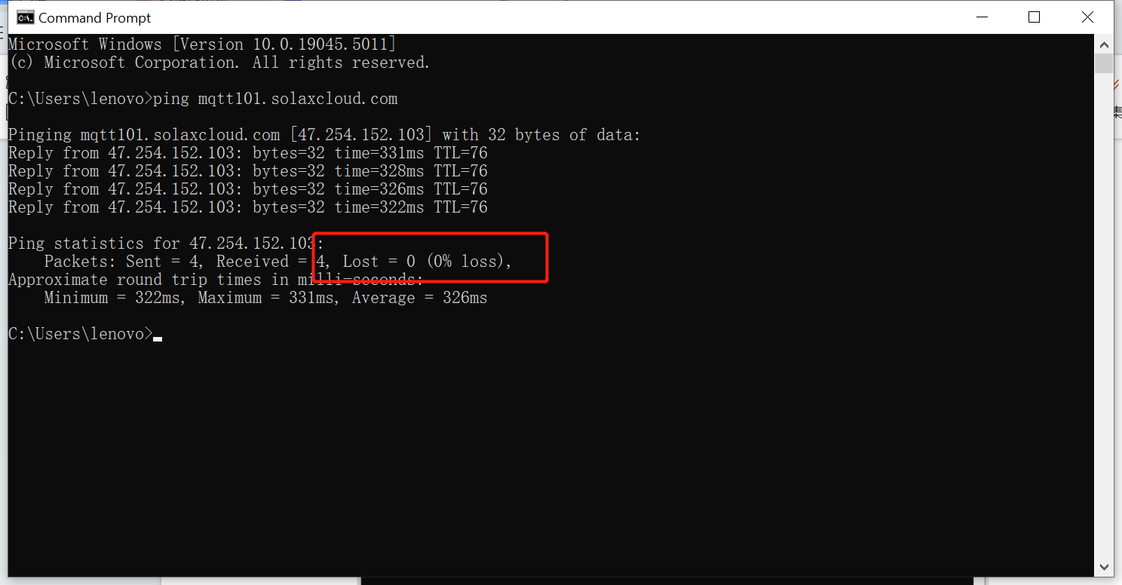
Step4: Check whether Pocket LAN can be found in the router. If not, check whether there is a blacklist or if the number of access connections exceeds the limit.
Information check list
If you have completed the above <Guidance for installer>, and the problem is still not solved, please collect the following troubleshooting information and send them to the R&D.
1.[Photo]SN number of the inverter and WiFi module, which should clearly display the registration number.
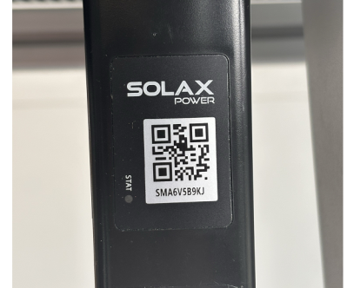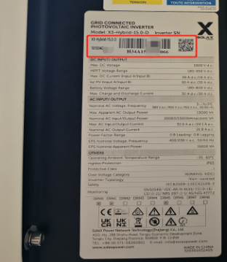
2.[Photo]The Register SN on the inverter LCD display.
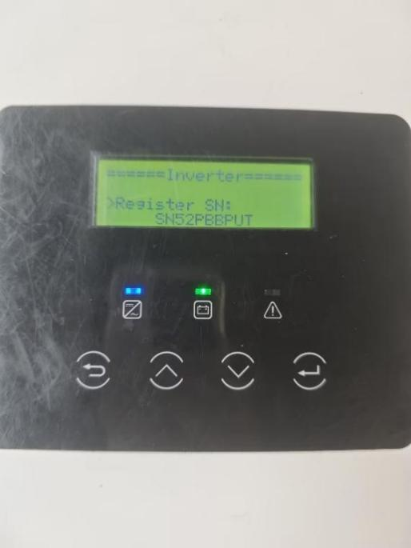
3.[Photo]The USB port of the dongle.
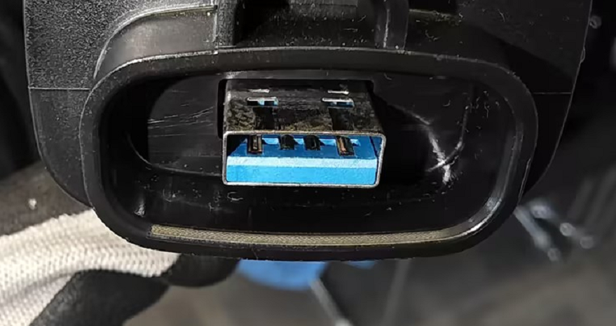
4.[Photo]The result of the Command Prompt.

5.[Video] Dongle indicator operation video.

